Hello!

If your institution is attending, the following is information for each NACRAO College Fair scheduled the week of **October 7th through October 11th.** Please forward this information to any representatives who will be attending these events. If you have any questions about an event, or will no longer be able to attend an event, please contact the host site directly (contact information is below). Also, new this year check out our **Weekly Socials** below for a chance to get together with the other reps on the road!

*As a reminder we are using [StriveScan](https://www.strivescan.com/) as our college fair scanning app! Be sure to purchase a per fair you wish to attend (only one credit needed per school). If you're not familiar with StriveScan, [you can watch a quick, 2-minute video on how it works](https://urldefense.com/v3/__https:/www.strivescan.com/*intro__;Iw!!I6-y8lpfja43!uRp08Esb-nX-rHwEJ429Oqv-AwriQbasJ48XrKdbEx20y75Btm2fbheddH7Lo1MdwWyXiuZJB_Z0-olv7Xf5$).

Monday, October 7th

**Hastings Area College Fair**

**9:00AM- 11:00AM**

**Hastings High School**

Address: 1100 W 14th St. Hastings NE

Host Site Contact: Jeff Bittfield, School Phone 402-461-7652, jeff.bittfield@hpstigers.org

Parking: The College Fair will be in the south gym. Representatives may park in the west parking at the corner of 14th St and Saunders Ave. You may also park along 14th St. and Saunders Ave. You can enter through the main entrance on the south side of the building (under the bridge). Reps may begin setting up any time after 8:30 am.

High Schools Invited: Adams Central Public Schools, Blue Hill Community Schools, Doniphan-Trubull High School, Harvard High School, Kenesaw Public Schools, Lawrence-Nelson Public Schools, Red Cloud Community Schools, Sandy Creek Public Schools, Silver Lake Public Schools, St. Cecilia Middle/High School, Superior Public Schools, Sutton Public Schools.

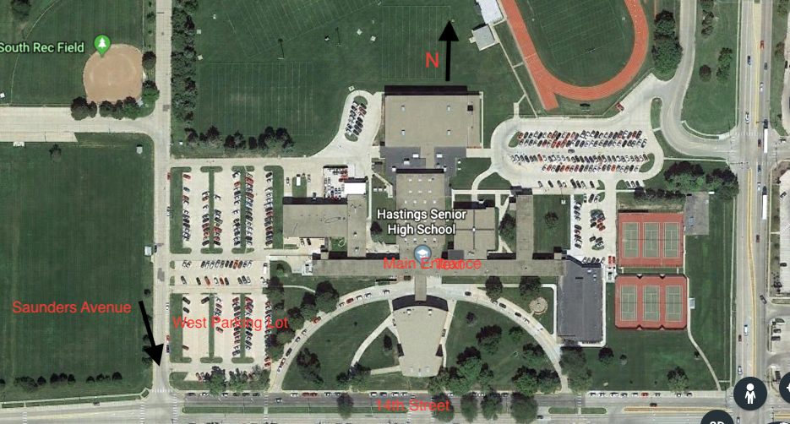

**GI Northwest Area College Fair**

**1:00-2:30 PM**

**Grand Island Northwest High School**

Address: 2710 N. North Road

Host Site Contact: Lori Merritt, School Phone 308-385-6394, [lmerritt@ginorthwest.org](mailto:lmerritt@ginorthwest.org)

Cell 308-391-1499

Parking: College Fair will be in the new gym. Representatives may park in the lot east of the school (along North rd) and the gravel lot to the east of the track.  You can enter through the main doors on the east side of the building (map is attached). Reps may begin setting up any time after 12:30 pm.  We will have student reps available to help carry items and direct you to the gym.

High schools Invited: Aurora, Central City, Centura, Doniphan, Elba, Fullerton, Giltner, GI Central Catholic, Giltner, Heartland Lutheran, Nebraska Christian, Palmer, St. Paul

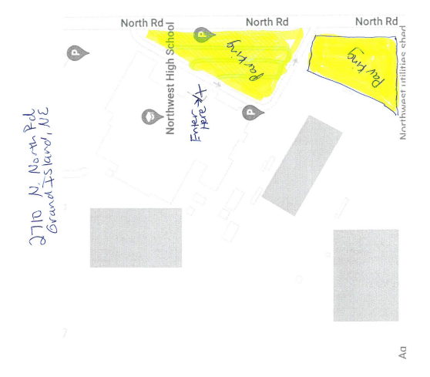

Tuesday, October 8th

**Grand Island High College Fair**

**8:00AM- 10:00AM**

**Grand Island Senior High School**

Address: 2124 N Lafayette Ave, Grand Island, NE 68803

Host Site Contact:

Parking: Please arrive on west side of GISH, see entrance and parking maps below. Enter through door #2 and will need to show a photo ID and will print out temporary ID sticker that must be worn while in the building. Please arrive between 7:00am and 7:30am to get processed into the building. If reps arrive later than 7:30 there will be a line of students at the door who are also getting their IDs processed and reps will get stuck in traffic at the front door.

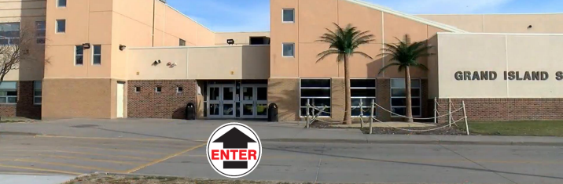

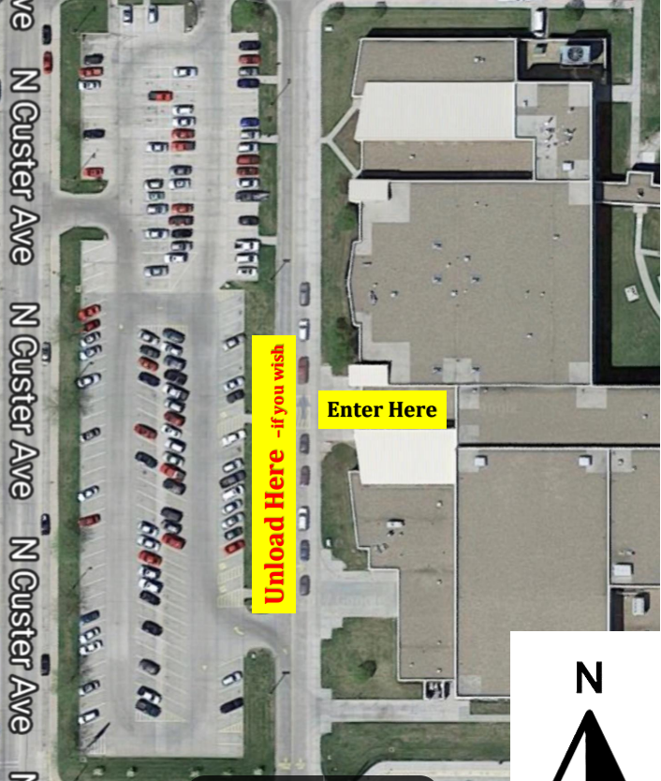

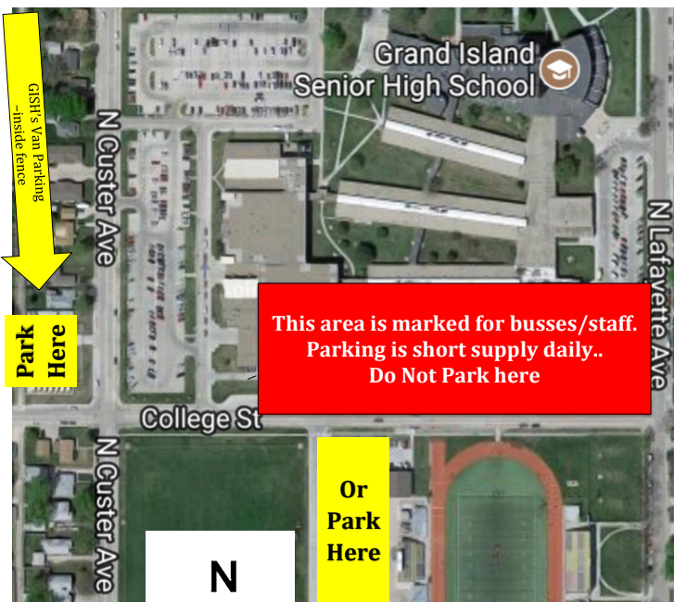

**Holdrege Area College Fair**

**1:00PM- 2:30PM**

**Holdrege High School**

Address: 600 12th Avenue, Holdrege, NE

Host Site Contact: Julie Freburg, School Phone 308-995-8988, julie.freburg@dusters.org

Cell 308-991-1744

Parking: College Fair will be in the gym. Representatives may park in the east parking lot or the south east front of the school.  You can enter through the front door on the south side of the building or the gym doors on the east. Reps may begin setting up any time after 12:00 pm.  Students will be available to help carry items and direct you to the gym.

High schools Invited: Alma, Arapahoe, Axtell, Bertrand, Franklin, Loomis, Southern Valley, Wilcox-Hildreth

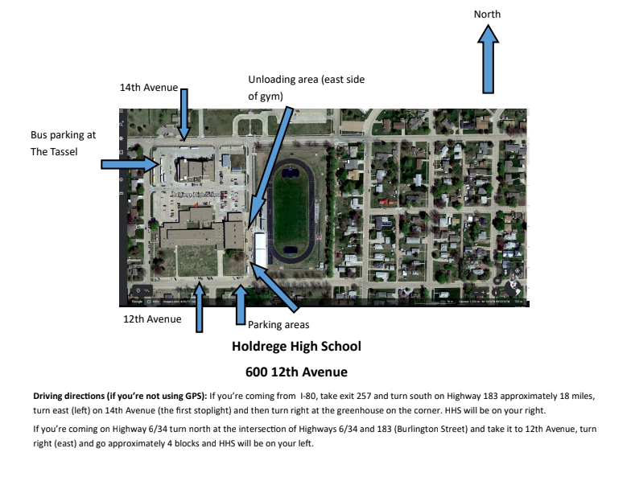

Weekly Social!  
Day: Tuesday, October 8th

Time: 6:30pm

Location: The Crafty Dog Sports Bar

Address: 1325 2nd Ave Ste A, Kearney NE

Wednesday, October 9th

**Kearney Area College Fair**

**9:00AM- 10:30AM**

**Kearney Catholic High School**

Address: 110 E 35th St. Kearney, NE 68847

Host Site Contact: Josh Pierce, School Phone 308-234-2610, josh.pierce@kearneycatholic.org

Parking: College Fair will be in the old gym. Representatives may park in the church parking lot north of the school.  You can enter through the door on the north side of the building. Reps may begin setting up any time after 8:30 am.  We will have students available to help carry items and direct you to the gym.

High schools Invited: Amherst, Axtell, Elm Creek, Gibbon, Kearney Senior High School, Minden, Pleasanton, Ravenna, Shelton

**Broken Bow Area College Fair**

**1:30PM-3:00PM**

**Broken Bow High School**

Address: 323 North 7th Ave Broken Bow NE 68822

Host Site Contact: Ed Schaaf, School Phone 308-872-2475, [ed.schaaf@bbps.org](mailto:ed.schaaf@bbps.org)

 Cell 308-870-4958

Parking: The college fair will be held at the HS gym. Parking is a challenge at BBHS due to our construction. Representatives may park anywhere they can find a spot. There are two gravel lots southeast of the HS.  You can enter through the main doors on the east side of the building. Reps may begin setting up any time after 12:45 pm.  Student reps will be available to help carry items and direct you to the gym.

High schools Invited: Anselmo-Merna High School, Ansley Public School, Arcadia Public Schools, Arnold High School, Callaway High School, Litchfield High School, Loup County Public School, Sandhills High School, Sargent Public Schools

Broken Bow will have grades 9-12 in attendance.

Grades 11-12 will attend 1:30 - 2:10

Grades 9-10 will attend 2:14 -3:00

Thursday, October 10th

**Ord Area College Fair**

**9:00AM- 10:00AM**

**Ord High School**

Address: 1800 K Street Ord NE 68862

Host Site Contact:  Lana Kruml School Phone 308-728-3241, [lkruml@ordps.org](mailto:lkruml@ordps.org) cell 308-201-1449

Parking: College Fair will be in the new gym/new commons. Representatives may park in the lot east of the school (N. 17th Street).  You can enter through the east doors on the east side of the building.  Reps may begin setting up any time after 8:15 a.m.  Most of the tables will be round tables.

High schools invited: Burwell, Central Valley, Loup City, Loup County, Riverside, Spalding Academy and Wheeler Central

**Ainsworth Area College Fair**

**1:00PM-2:00PM**

**Ainsworth High School**

Address: 520 East 2nd, Ainsworth, NE 68210

Host Contact: School Phone 402-387-2082, Lisa Schlueter, schlueter@ainsworthschools.org

Parking: College Fair will be in the gym on the south west side of the school.

Representatives may park on the northwest or southwest part of the school and surrounding

streets. You can enter through the door on the north west of the building titled Big A. Reps

may begin setting up any time after 12:00pm.

High schools Invited: Cody-Kilgore, Keya Paha, Rock County, Valentine

Friday, October 11th

**O’Neill Area College Fair**

**9:00AM-10:30AM**

**Location: O’Neill High School**

Address: 540 E Hynes Ave, O’Neill NE

Host Contact: Cole Hilker; 402-335-2667; [colehilker@oneillschools.org](mailto:colehilker@oneillschools.org)

Parking: Parking on the street just south of the high school, Hynes Street. Please come through the main entrance of the school. The gym will be ready for set up at 8:30am. Tables will be 1st come first serve.